WHERE-TO-BE / WHAT-TO-DO
2019 SOLAR CAR CHALLENGE
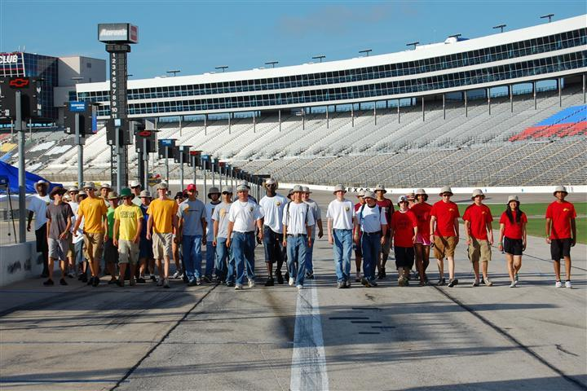
Thursday
July 11 .
10:00 AM Judges Training Workshop [10:00 AM – 3:00 PM]
Media Center, Infield, Texas Motor Speedway
Lunch provided

11:00 PM Check-In [11:00 AM – 6:00 PM]
Teams will be assigned a time to arrive for Team Check-In
Golf Club House, DFW Marriott & Golf Club
All race participants must attend Team Check-In

Teams need to bring the following:
- SCC Release of Liability Form signed by parents
- TMS Release of Liability Forms (adult and minors)
- Signed Guidelines for Photographing/Filming
- All drivers verify their driver’s licenses [Driver Check-In]
[Wristbands awarded when driver completes Scrutineering Station 4]
- Teams with more than 14 people (students, teachers, chaperones] make arrangements for “extra person fee”
- Purchase tickets for Awards Banquet - $35/person
- Supply documents to complete Final Race Registration packet
- Turn in Solar Car Liability Insurance Certificate
- Bring radio planned for race to coordinate channel

Teams will receive:
(1) 14 tee shirts
(2) 50 Official Race Booklets
(3) Traditional “baking soda” for environmental spills
(4) Rule Booklet and “Final Where-to-Be What-to-Do” Document
(5) Official Scrutineering Packet
(6) Race Identification badges for all race participants
(7) Draw for Starting Order, Garage, Pit Row, Oral Presentation
(8) Solar Car Challenge Event Patch for Students
(9) Welding blanket for use in garage

7:00 PM Required All-Team Meeting
All race participants must attend All-Team Meeting
Ballroom, 9th Floor, TMS Speedway Club

7:45 PM Team Safety Officer Meeting [required]
Teams must send an Adult and the Team Safety Officer
Ballroom, 9th Floor, TMS Speedway Club

7:45 PM Drivers Meeting [required]
Team drivers must attend
Chisolm Train Room, 4th Floor, TMS Speedway Club

Friday
July 12
6:30 AM Judges Meet at Garages for Scrutineering

7:00 AM Scrutineering Day One
Teams get access to Texas Motor Speedway. Staff will show
teams their designated garage and pit row space .

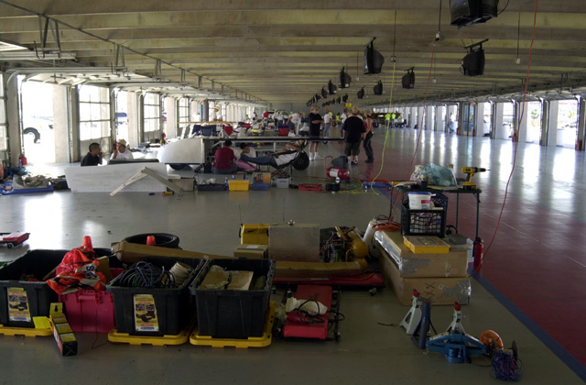

8:00 AM Scrutineering Session No. 1 [8:00 AM – 6:00 PM]
All cars must be ready to begin Scrutineering at 8:00 AM or will receive a significant penalty. [Rule 7.1]

6:00 PM Scrutineering Session No. 1 Ends
Garages will remain open until 9:00 PM so that teams can continue working on solar cars.

6:30 PM Race Staff Meeting and Dinner
Golf Club House, DFW Marriot & Golf Club
Saturday
July 13
6:30 AM Judges meet at Garages for Scrutineering

7:00 AM Scrutineering Day Two
Teams get access to Texas Motor Speedway

8:00 AM Scrutineering Session No. 2 [8: 00 AM – 6:00 PM]

8:00 AM Oral Presentations Session 1 [10:00 AM – 5:00 PM]
Judging by Texas A&M Engineering Staff and SCC Race Staff
Teams submit their hard copy Scrapbook for evaluation
Media Center Auditorium, Texas Motor Speedway

6:00 PM Garages Close

7:30 PM Opening Banquet
Ballroom, 9th Floor, Speedway Club, Texas Motor Speedway
All participants must wear their Official Race Badges
- Team Captains need to be prepared to introduce teams
- Announce Early Awards

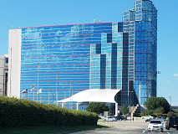

Sunday
July 14
6:30 AM Judges meet at Garages for Scrutineering

7:00 AM Scrutineering Day Three
Teams get access to Texas Motor Speedway

8:00 AM Scrutineering Session No. 3 [8: 00 AM – 8:00 PM]
Teams not qualifying by 8:00 PM will not be able to take part
in the 2019 Solar Car Challenge.

8:00 AM Oral Presentations Session 2 [8:00 AM – 10:00 AM]
Judging by Texas A&M Engineering and Race Staff
Teams submit their hard copy Scrapbook for evaluation
Media Center Auditorium, Texas Motor Speedway

10:00 AM Media Day Events at Texas Motor Speedway
Teams must have their solar car and team members on display
and available to meet media North of the Media Center. We will
take the Official Race Photo at this time..
[Scrutineering suspended until Team Photo is completed]

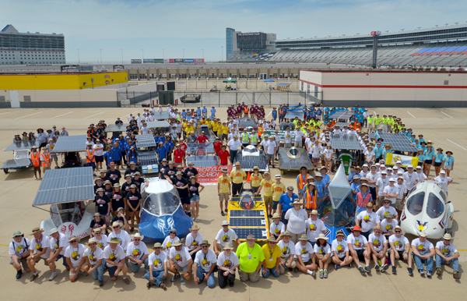

12:00 PM The SCC will provide Dominos Pizza and Ice Cream for teams
West End of the CUP Garage

8:00 PM Official Scrutineering Ends

9:00 PM Garages Close
Monday
July 15
6:30 AM Teams get access to Texas Motor Speedway.
Judges will meet teams at the CUP Garage.

8:00 AM Required Teams Meeting
All Team Members Must Attend
West End of CUP Garage

8:45 AM Solar Cars lined up in pit row for RACE START
Starting Order based on Team Check-In Drawing. Teams start racing every minute. Any team not ready at their prescribed time will take a position at the end of the Starting Order Line.

8:50 AM OPENING CEREMONIES
9:00 AM FIRST RACE DAY BEGINS – All Divisions

RACING PERIODS:
Classic Division, Advanced Classic Division, and Electric-Solar Power Division vehicles will race from 9:00 AM – 12:00 PM, and 2:00 PM – 5:00 PM. The Advanced Division vehicles will race from 9:00 AM – 5:00 PM with a required 30 minutes off-track rest period. Teams must use all of their 30 minutes at one time.

9:00 AM Forever Laps posted on Media Center Auditorium Door

12:00 PM End of racing for Classic Division, Advanced Classic, and Electric-Solar Powered Division vehicles

1:45 PM Classic, Advanced Classic, and Electric Vehicles lined up in pit row for Re-Start

2:00 PM Racing resumes for Classic Division, Advanced Classic Division, and Electric-Solar Powered vehicles

5:00 PM END RACING DAY FOR ALL VEHICLES.
Teams come off track in staggered order based on Starting Order

6:00 PM Solar Car Challenge provides a Texas Bar-B-Q Dinner
West end of the CUP Garage

7:00 PM Judges Meeting – Media Center

9:00 PM Vehicles Impounded in Texas Motor Speedway Garages.
[Teams have no more access to solar cars]
Tuesday
July 16
6:30 AM Teams get access to Texas Motor Speedway.
Judges will meet teams at the CUP Garage.

8:00 AM Required Teams Meeting
All Team Members Must Attend
West End of CUP Garage

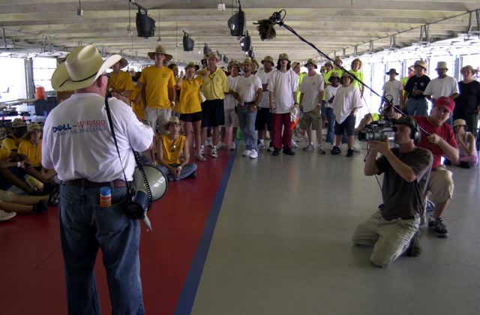

8:45 AM Solar Cars lined up in pit row for RACE START
The Starting Order in each division will be based on the official number of laps earned during the preceding day of racing. Teams start racing every minute. Any team not ready at their prescribed time will take a position at the end of the Starting Order Line.

9:00 AM SECOND RACE DAY BEGINS – All Divisions

12:00 PM End of racing for Classic Division, Advanced Classic Division, and Electric-Solar Powered vehicles

1:45 PM Classic, Advanced Classic, and Electric Vehicles lined up in pit row for Re-Start

2:00 PM Racing resumes for Classic Division, Advanced Classic Division, and Electric-Solar Powered vehicles

5:00 PM END RACING DAY FOR ALL VEHICLES.
Teams come off the track in staggered order based on Starting Order
6:00 PM Solar Car Challenge provides a Mexican Food Dinner
West end of the CUP Garage

7:00 PM Judges Meeting

9:00 PM Vehicles Impounded in Texas Motor Speedway Garages.

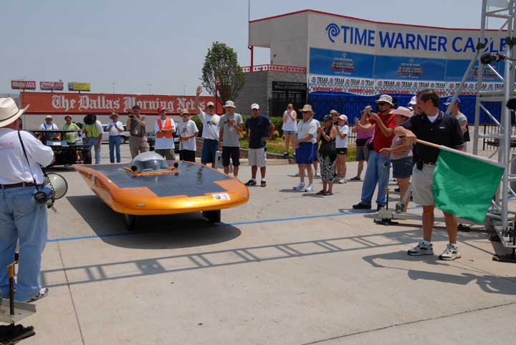
Wednesday
July 17
6:30 AM Teams get access to Texas Motor Speedway.
Judges will meet teams at the CUP Garage.

8:00 AM Required Teams Meeting
All Team Members Must Attend
West End of CUP Garage

8:45 AM Solar Cars lined up in pit row for RACE START
The Starting Order in each division will be based on the official number of laps earned during the preceding day of racing. Teams start racing every minute. Any team not ready at their prescribed time will take a position at the end of the Starting Order Line.
9:00 AM THIRD RACE DAY BEGINS – All Divisions

12:00 PM End of racing for Classic Division, Advanced Classic Division, and Electric-Solar Powered vehicles

1:45 PM Classic, Advanced Classic, and Electric Vehicles lined up in pit row for Re-Start

2:00 PM Racing resumes for Classic Division, Advanced Classic, and Electric-Solar Powered vehicles

5:00 PM END RACING DAY FOR ALL VEHICLES.
Teams come off the track in staggered order based on Starting Order

6:00 PM SCC provides Chopped Brisket Sandwich Dinner
West end of the CUP Garage

7:00 PM Judges Meeting

9:00 PM Vehicles Impounded in Texas Motor Speedway Garages

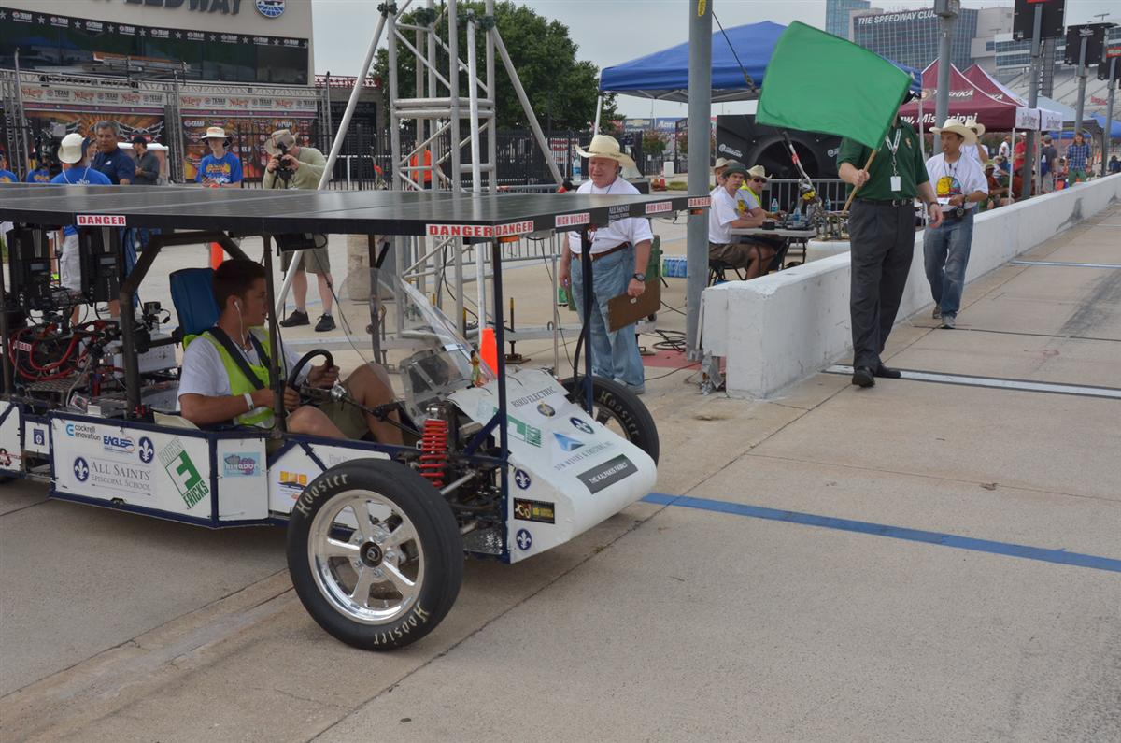
Thursday
July 18
6:30 AM Teams get access to Texas Motor Speedway.
Judges will meet teams at the CUP Garage.

8:00 AM Required Teams Meeting
All Team Members Must Attend
West End of CUP Garage

8:45 AM Solar Cars lined up in pit row for RACE START
The Starting Order in each division will be based on the official number of laps earned during the preceding day of racing. Teams start racing every minute. Any team not ready at their prescribed time will take a position at the end of the Starting Order Line.

9:00 AM FOURTH RACE DAY BEGINS – All Divisions

12:00 PM End of racing for Classic Division. Advanced Classic Division, and Electric-Solar Powered vehicles
1:45 PM Classic, Advanced Classic, and Electric Vehicles lined up in pit row for Re-Start

2:00 PM Racing resumes for Classic Division and Electric-Solar
Powered vehicles

4:00 PM END RACING DAY FOR ALL VEHICLES.
Teams come off the track in staggered order based on Starting Order

5:00 PM Teams must leave Texas Motor Speedway. Everything must be out of the Garages by 5:30 PM.

TURN IN RADIOS AS YOU EXIT THE SPEEDWAY
Race Staff will get radios as you exit through the South Gate

7:30 PM AWARDS BANQUET [Purchase tickets in advance]
Ballroom, 9th Floor, Texas Motor Speedway Club

Team Captains will be called on to share their race experiences. Be prepared to make a one-minute speech!
[The Race will ask up to 10 Team Captains to speak]

Please note that teams are responsible for their solar cars
after the End-of-Race on Thursday.

